The best Spanish sportmen - https://www.englishexercises.org/exercise.asp?id=2451#a

Holidays - https://www.englishexercises.org/makeagame/viewgame.asp?id=6578

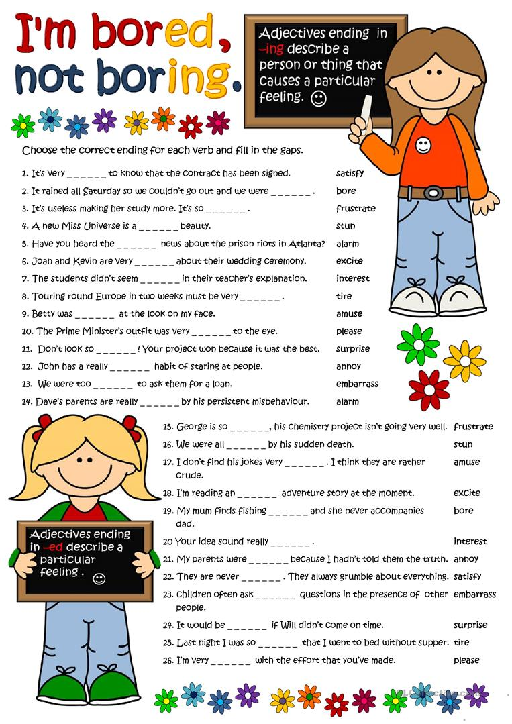
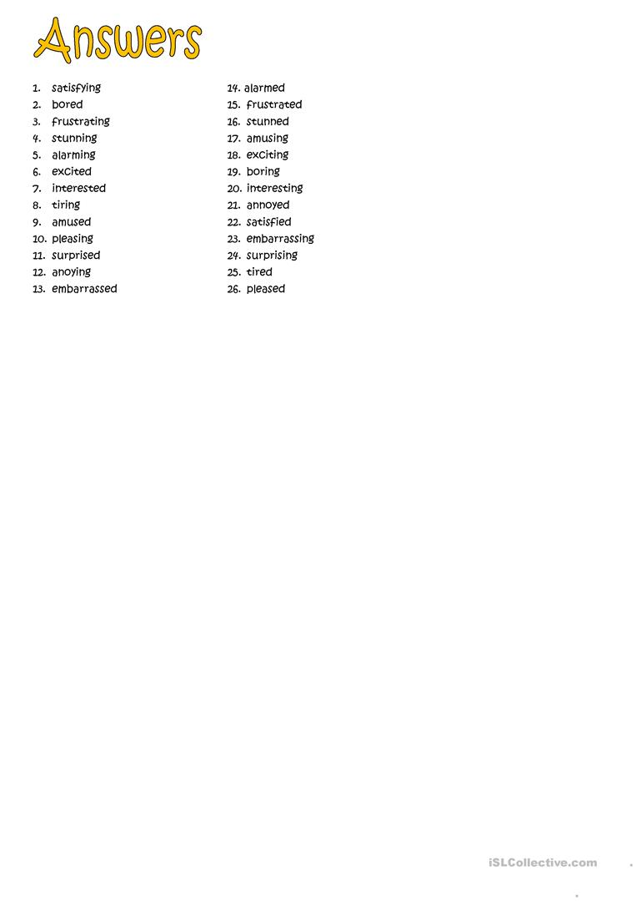

4.

